Part ID: 230400 - MAC Bucket with Rubber Auger
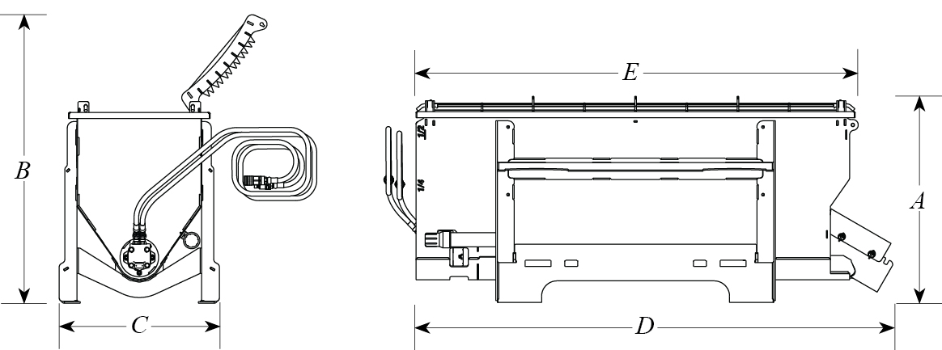
- Capacity
1/2 yard (13.5 cubic ft.); up to 3/4 yard (20 cubic ft.) with optional hopper extension
- Concrete Mix Capacity (80-lb bags)
Approx. 18 (1/2 yd)
Approx. 25 (3/4 yd)
- Dispense Rate
28 seconds @ 24 GPM
- Hydraulic Requirements
Up to 24 GPM
Up to 3,500 PSI
- Mounting Options
Skid-Steer Quick Attach
- Height, Grate Lowered (A) (inches)
33.5"
- Height, Grate Open (B) (inches)
47"
- Overall Width (C) (inches)
26"
- Overall Length (D) (inches)
77.4"
- Overall Hopper Length (E) (inches)
71.3"
- Weight
615 lb.
- Auger Diameter without Rubber (inches)
4"
- Auger Diameter with Rubber (inches)
6.5"
- Center Column Diameter (inches)
1.32" O.D.
.18" wall
- Auger Length (inches)
60"
- Flighting Spacing (inches)
4"

